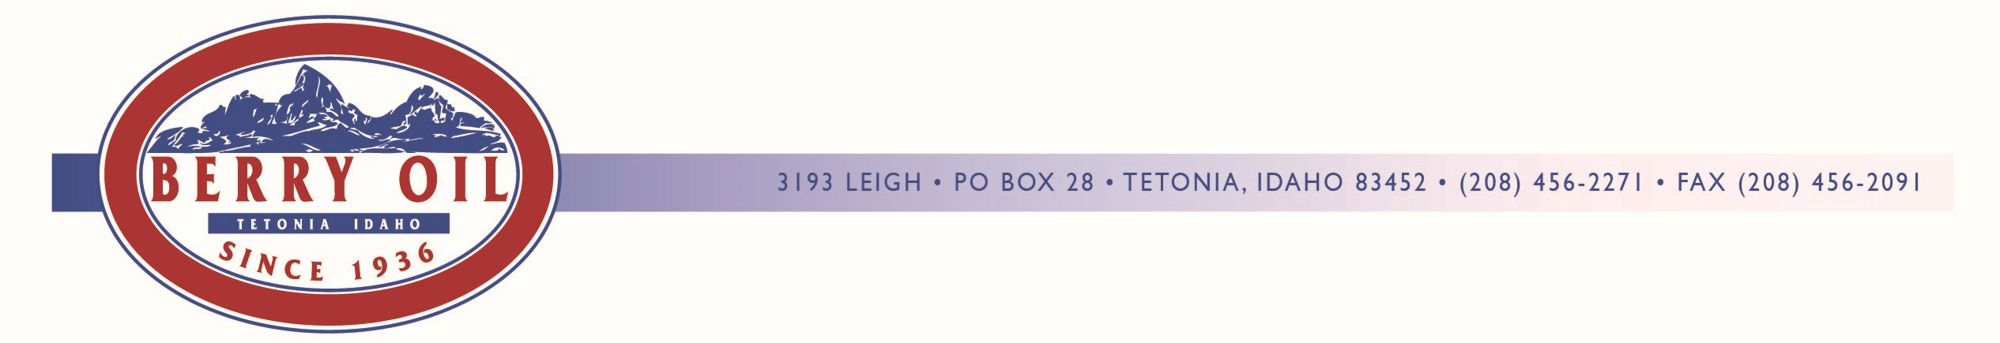
Dear Valued Customer;

In an effort to offer more customer convenience, are informing you of two options to make monthly billing hassle free. Monthly statements and invoices can be emailed directly to you free of charge.

Additionally, we offer a fast, secure, and convenient EZ Pay option, which debits your bank account for your monthly bill at your request. You can set up the automatic withdrawal on a date convenient to your payment schedule.

If you are interested in any of these services, please fill out the appropriate form below and return with your payment, or you can email the information back to ar@berryoil.com.

Sign me up to receive my statements and invoices via email:

Account Name and/or Number_________________________________________________

Email Adress_______________________________________________________________

Sign me up for the EFT Payment Option:

Name________________________________ Bank_______________________________

Routing #____________________________Account #_____________________________

Circle One: Pay auto on 10th of month Pay upon phone authorization

I hereby authorize the above account to be electronically debited by Berry Oil. Berry Oil shall initiate debit or credit entries to Customers’ account as indicted above, and does hereby authorize the financial institution named above to debit or credit such entries to the customer’s account.

Authorized Signature: ________________________________________________________
Date
Please Note: All information is confidential and is only used for the purposes offered.

